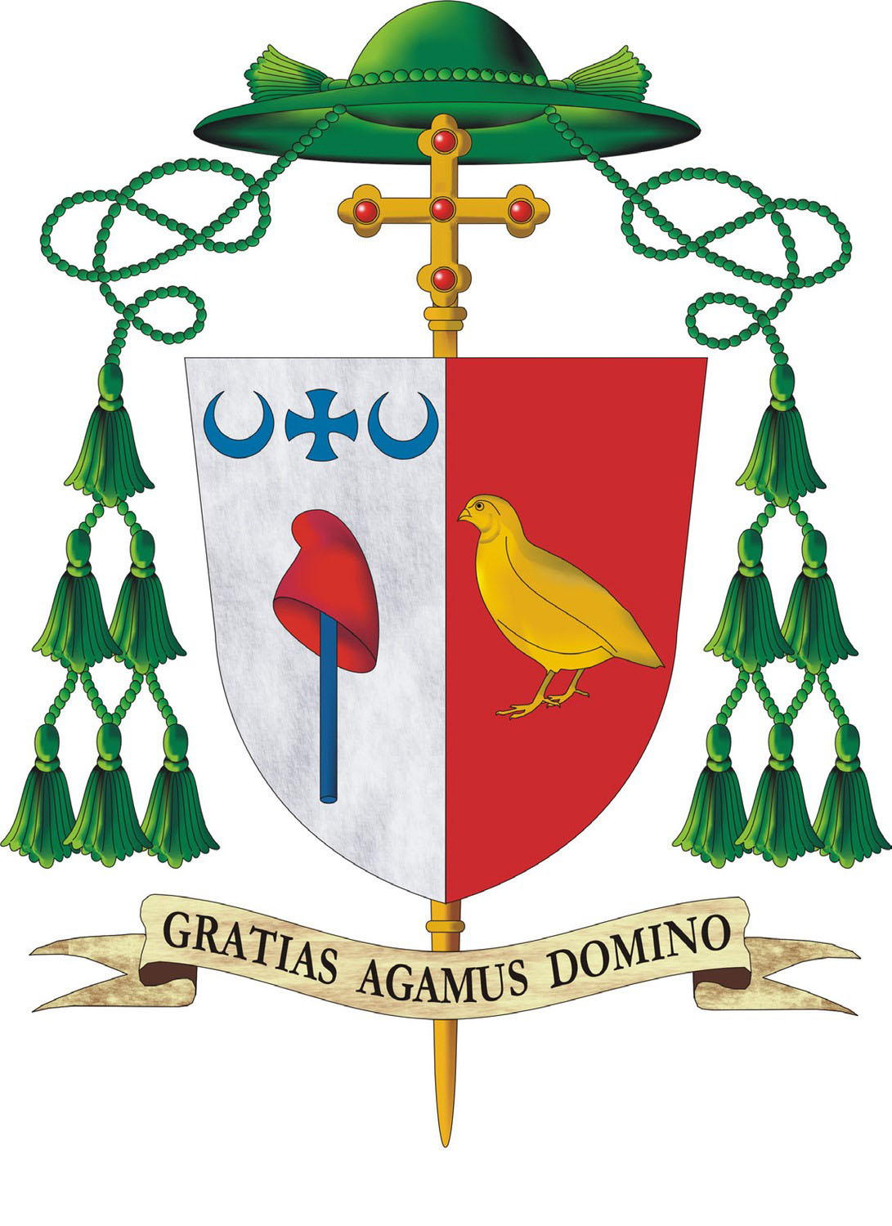 | Diocese of Jefferson City  Office of the Bishop
1 June 2019

Dear Faithful of the Diocese of Jefferson City,
As the great feast of Pentecost draws near, I ask you to prayerfully consider supporting two special collections which fund modern-day efforts to spread the Good News, similar to how the outpouring of the Holy Spirit encouraged the first Christians to proclaim Christ’s salvation “to the ends of the earth.”
During our liturgies on the weekend of Pentecost, June 9, we will take a special collection for the Catholic Communication Campaign and The Catholic University of America.
In the Philippines, the island of Samar is home to nearly two million people, about 90% of whom are Catholic. Radio is a critical source of information for those who live in remote villages. The Catholic Church has provided the people of Samar with spiritual programming through a dedicated radio station for 20 years. But in 2013, Typhoon Haiyan destroyed the entire radio station, effectively isolating many from important life-sustaining information and spiritual solace during a very difficult situation. The Catholic Communication Campaign is providing funds to assist in the rebuilding of the radio station.
The Catholic University of America in Washington, D.C. shares the Good News by engaging its students to discover knowledge and truth through excellence in teaching and research. With its 12 schools and 23 research centers, the University provides an exceptional Catholic education to almost 7,000 students annually. By way of its many programs, such as those in ethical business practices; classical architecture; intelligence studies; neuroscience; nursing; Spanish language and Hispanic ministry; social service; and Catholic bioethics the University prepares students to respond to the many issues facing the Church and society today.
Your generous support for the Catholic Communication Campaign and for The Catholic University of America ensures that many people, from the villagers on the remote island of Samar to the next generation of lay leaders being educated at CUA, can receive the Gospel and have their lives transformed. Thank you for your prayerful support of these two special collections.
With my prayers that God bless you richly with the gifts of the Holy Spirit, I am

Sincerely yours in Christ,

Most Reverend W. Shawn McKnight, S.T.D.
Bishop of Jefferson City

